Connecting Laptop to TV in Narthex
- Turn On TV in Narthex

- On laptop in Sifers Hall, if the HDMI cable is plugged in to the TV, unplug it.
CANNOT CONNECT TO MORE THAN ONE TV AT A TIME.
- Select 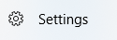 on the taskbar at the bottom

- Select SYSTEM

- Under MULTIPLE DISPLAYS: Select Connect to “Wireless Display”

- On the right hand side of the screen you will see IOGEAR-F2F56F device. This is the name of the TV in the Narthex.

- Select the IOGEAR-F2F56F device. It will show “Connected” You will see the following display.
Screen of PC is now connected to TV
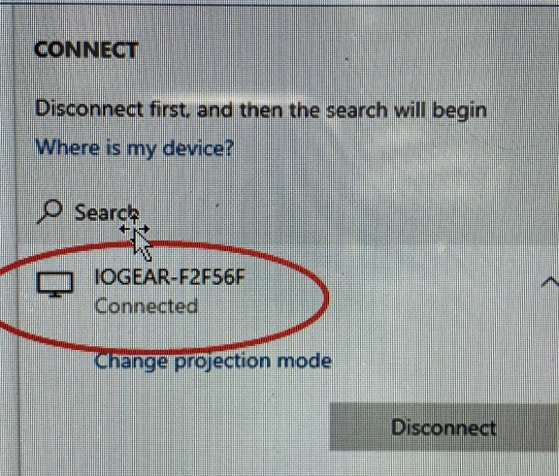

- You may now do any task on the PC: Open a Powerpoint presentation, Facebook LIVE, ZOOM, or any office product.

- When done, DISCONNECT and turn off TV in the Narthex.

